**Observer**

Event Name: checkout_onepage_controller_success_action-> use for get current order id after place order.

event name="sales_model_service_quote_submit_before"-> use for save custom data from quote table into sales order table .OR convert quote table to sales order table.

event name="controller_action_predispatch_checkout_index_index" -> use for display error message when click on proceed to checkout button on shopping cart page .when prescription required for that product and not uploaded by customer.

**Plugin**

type name="Magento\Checkout\Block\Checkout\LayoutProcessor” -> use for hide discount quopon and product image in order summary.

Function: public function afterProcess()

<type name="Magento\Checkout\Model\ShippingInformationManagement" -> use for display error message on checkout shipping page when click Next button.

Function: public function beforeSaveAddressInformation();

<type name="Magento\Quote\Model\Quote\Item\ToOrderItem"> -> user for save custom product attribute in sales_order_item table.

Function: public function aroundConvert();

<type name="Magento\Sales\Model\Order"> ->use for display error message before place order.

Magento 2.3.5 p2 installation error

1. Wrong file in D:\xampp7.2\htdocs\M235P-2\vendor\magento\framework\Image\Adapter\Gd2.php:64

Solution:

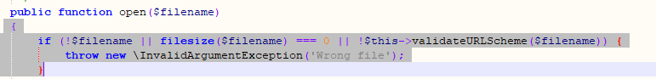

Replace this code by

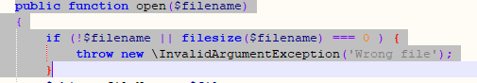



**How to Resolve Blank page Issue after installing Magento 2.x**

[**https://magecomp.com/blog/resolve-blank-page-issue-while-installing-magento-2/**](https://magecomp.com/blog/resolve-blank-page-issue-while-installing-magento-2/)

**when error occure in module-backend/Model/View/Result/Page.php line 27 then**

**you will delete generated/metadata file**

**Magento 2 module enable disable from admin**

1. **System.xml**
2. **Helper/Data.php**
3. **Cal helper function in template file.**

**Interface**: Collection of abstract method is called interface.

All methods which is defined under interface will be public and abstract.

All variable of the interface must be public+static+final.

**Admin grid**

1. admin controller index.php

2. menu.xml and call controller in menu.xml

3. Routes.xml

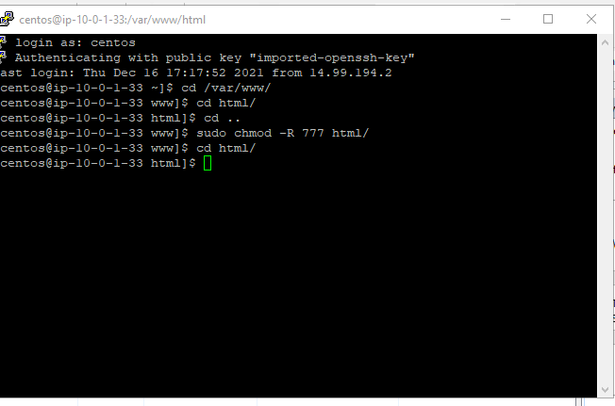

Postman:

